**Project Documentation Guidelines**

Front page - Project name, Team name and Student name and roll numbers

Index / Table of contents

Abstract

1. Preview for the project - Introduction, need and motivation, tools used
2. Product Backlog
   1. Report of your product backlog from JIRA
   2. Epic 1
      1. Epic 1 stories
   3. Epic 2
      1. Epic 2 stories
   4. ….
   5. Epic n
      1. Epic n stories
3. Usecase diagram ERD if database used otherwise Class Diagram
4. Scrum activities
   1. Sprint 1 backlog
   2. Sprint 1 retrospective notes (If retrospective has been performed)
   3. Sprint 2 backlog
5. Implementation
6. Sample Code
7. Software Engineering tools used
   1. Static Code analysis (SonarQube)
      1. Screenshots/report of the scanning results
      2. Actions taken
      3. Any additional details
   2. Unit Testing
      1. Tool used and its setup details
      2. Test cases statistics (#Units in the code and #unit tests written for each unit)
      3. Test case code
   3. UI Testing
      1. Tool used and its setup details
      2. Test cases statistics (#UI pages in the project and #UI tests written)
      3. Test case code
   4. Continuous Integration (Optional – keep it only if this is done as part of your project)
      1. Tools used (e.g. Jenkins, Maven, Ant etc)
      2. Brief description of how CI has been done
      3. Any analysis/findings
8. Screen shots of Project
9. Conclusion

Students have to submit a soft binded Project Report

**Report of your product backlog from JIRA**

1. In Jira, once logged in, go to search bar and click “View all issues”.
2. Make sure in the search page, You have chosen your project, Type:All, Status:All, and Assignee:All
3. Click on export and select CSV(All Fields)

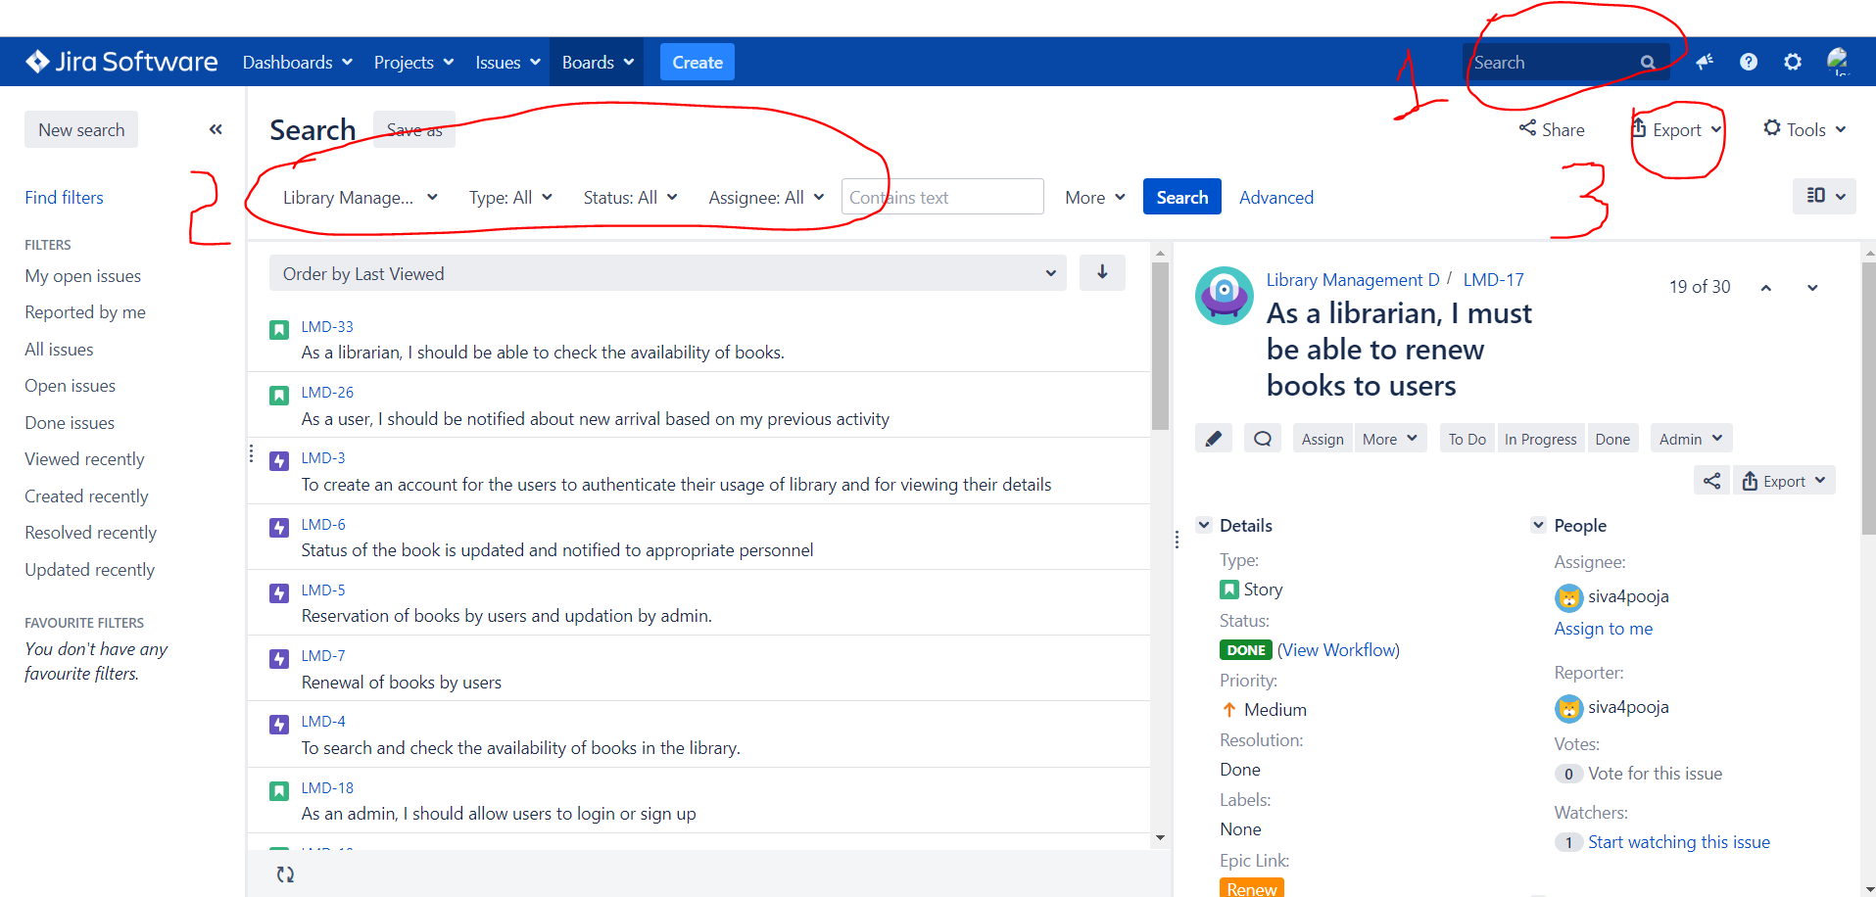

1. In that CSV file, keep only the following fields and that table can be kept as the product backlog report.

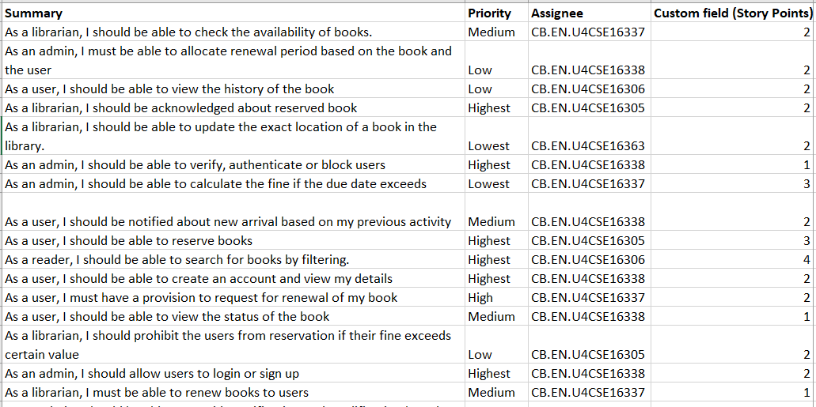

***For Sprint 1 backlog report,***

go to Reports🡪 Sprint Report 🡪 Select Sprint 1. You can see Sprint 1 backlog 🡪 Click on “View Issue in Navigator”

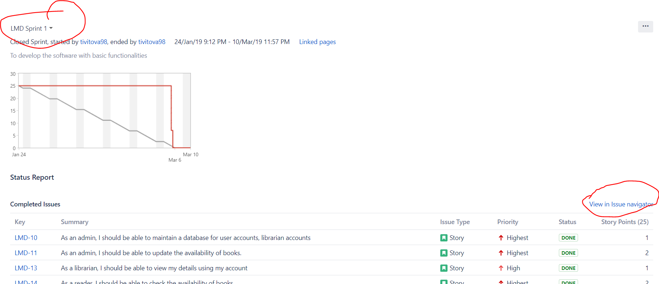

Click “Export” 🡪 Word

***For sprint 2 backlog, Print cards***

1. Go to “Backlog”
2. Click on the arrow next to “Board” and click “Print Cards”
3. And Click print

